Bottom-Up Processing

Individual elements to whole; analysis begins with sensory receptors and works up to brain’s integration of sensory info

Top-Down
Processing

Whole to the parts; info processing guided by higher-level mental processes, like our own experience and expectations

Agonist
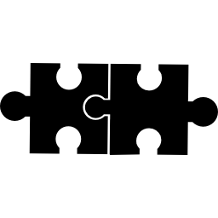

Chemicals that mimic the actions of neurotransmitter; stimulates a response by binding to a receptor site

Antagonist

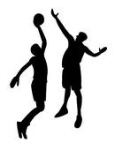

Chemicals that oppose action of a neurotransmitter; inhibits or blocks a response by binding to receptor site

Foot-in-the-Door


Start small then go big (ex. $5 first, then $100)

Door-in-the-Face
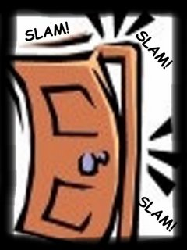

Start big to get to small (ex. If you want a skateboard, ask for a car)

Random Assignment

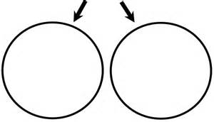

Each participant has equal chance of being placed into any group

Random Sample
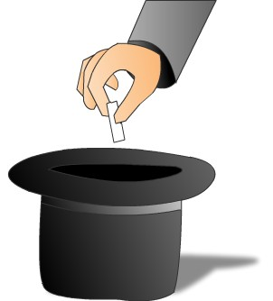

Process of choosing the research participants from the population; happens before the assignment

Applied Research
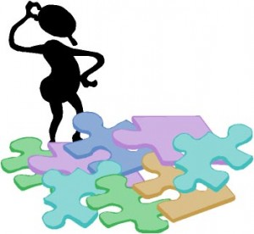

Clear, practical use; scientific study that aims to solve practical problems

Basic Research


Pure science that aims to increase the scientific knowledge base

Quantitative Data
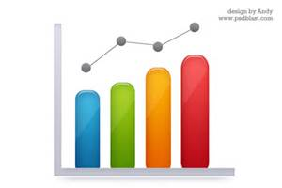

Deals with numbers-height, weight, time

Qualitative Data


Deals with description- color, smell, taste

Self-Serving Bias

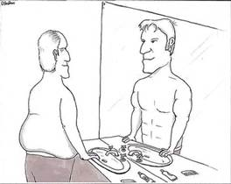

Tendency to overstate one’s role in a positive venture & underestimate in a failure

Self-Fulfilling Prophecies



Explains how people’s ideas about others can shape the behavior of those others

Collectivist Cultures
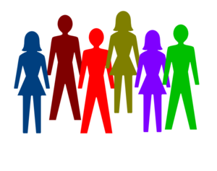

Japan (Eastern), family/group stressed

Collectivism: Giving priority to the goals of one’s group and defining one’s identity accordingly

Individualistic Cultures

USA (Western), uniqueness of individual stressed

Individualism: Giving priority to one’s own goals over group goals and defining one’s identity in terms of personal attributes rather than group identifications

Structuralism
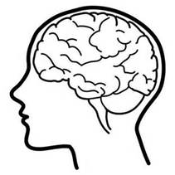

School of thought that thought the structure (parts of the brain) and elements of immediate, conscious experience to be proper subject matter of psychology- Wundt, Titchener (USA)

*Introspection

Functionalism
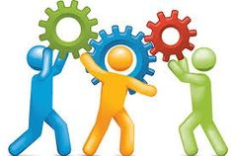

School of thought that tried to understand how & why the mind functions and is related to consciousness- James

Descriptive Statistics

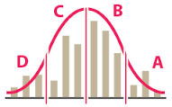
Numerical data used to measure and describe characteristics of groups. Includes measures of central tendency (mean, mode, median)
and measures of variation (standard deviation)

Inferential Statistics

Numerical data that allow one to generalize – to infer from sample data the probability of something being true of a population

Statistically Significant-Results not due to chance

Syntax
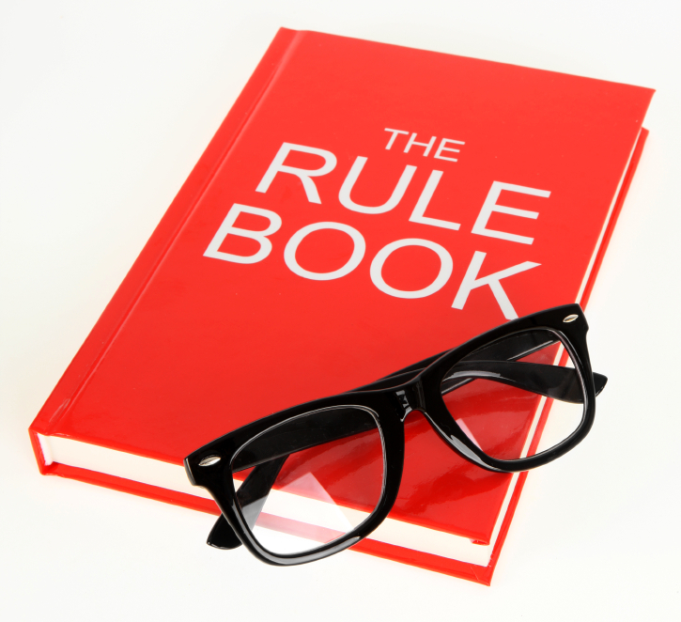

Arrangement of words and phrases to create well-formed sentences in a language; Grammar

Semantics
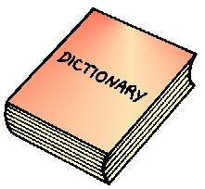

The meaning of a word, phrase, sentence, or text

Anterograde amnesia
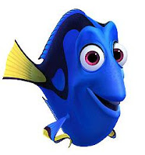

An inability to form new memories

Patient H.M.

Damage in Hippocampus

Retrograde Amnesia

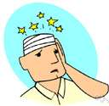

An inability to retrieve information from one’s past

Systematic desensitization


Type of exposure therapy that associates a pleasant, relaxed state with gradually increasing anxiety-triggering stimuli.

Commonly used to treat phobias.

Aversion Conditioning
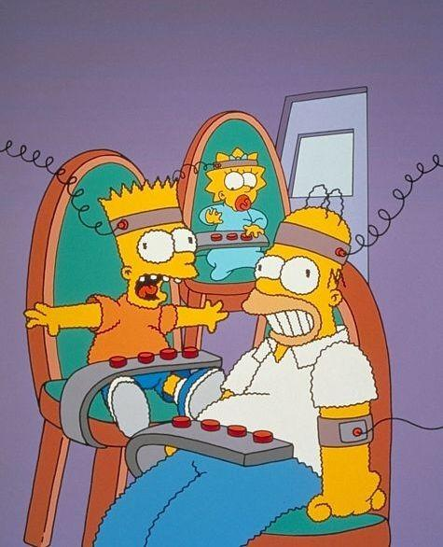

Behavior therapy in which an aversive stimulus is paired to elicit an undesirable response

Ex. bad behavior followed by shock

Absolute Threshold

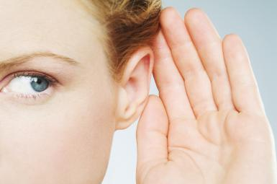

Level needed to detect stimulus 50% of the time

Just-noticeable difference (JND)
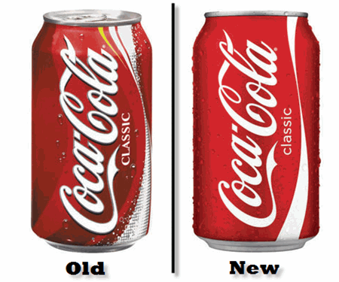

Adjustment needed to perceive change in stimulus level- ex. music level

Construct Validity
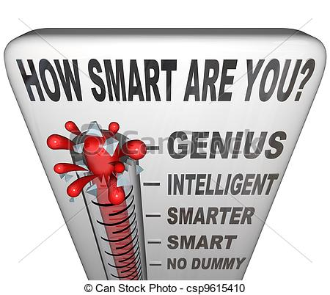

whether a scale or test measures the construct
adequately.

Ex. measurement of the human brain-intelligence, creativity level of emotion, proficiency or ability

Content Validity



Content of a test is representative of the domain it is supposed to cover

Ex. Unit test covers info from that chapter

Independent Variable
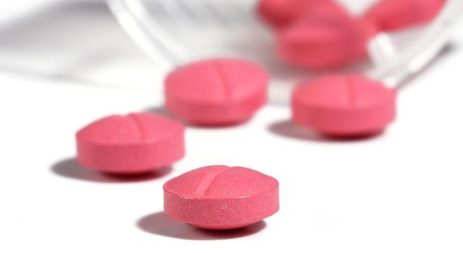

Variable that is being tested

Ex. Drug, treatment, condition

Dependent variable

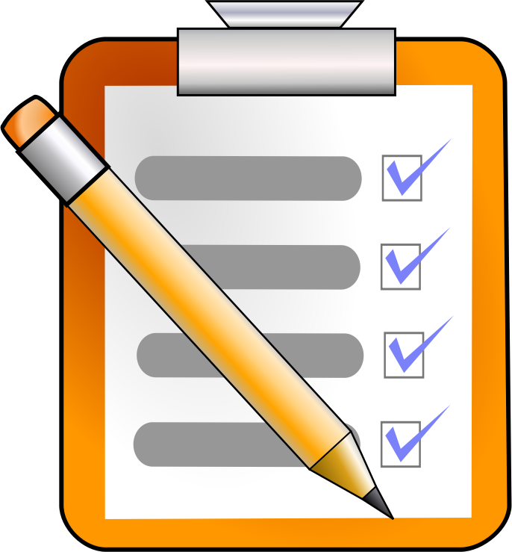

What is being measured

Ex. Test score, change in behavior, frequency of responses

Experimental Group
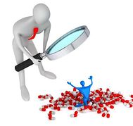

Group that is tested; given the IV

Control Group



Compared to the experimental, receives the placebo in a drug experiment.

No IV applied

Left brain
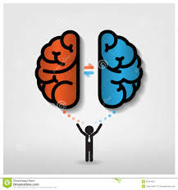

Language and logic

Right brain

Creative and spatial, faces

Corpus Callosum
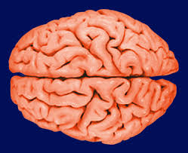

Band of fibers that connect left and right hemisphere.
Cut for split brain procedure (epilepsy)

Cerebral Cortex
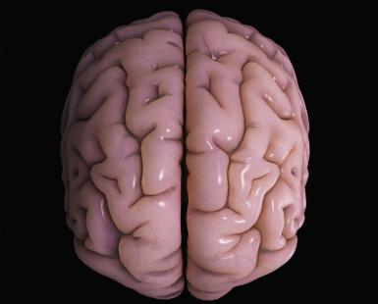

“bark” that covers the brain; fissures/wrinkles increases surface area of brain

Sympathetic nervous system


Arouses in response to stimuli

“fight or flight”

Parasympathetic nervous system
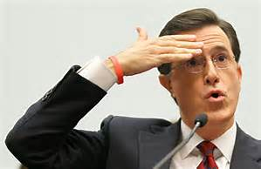

Calming; responses back to normal

Neurotransmitters
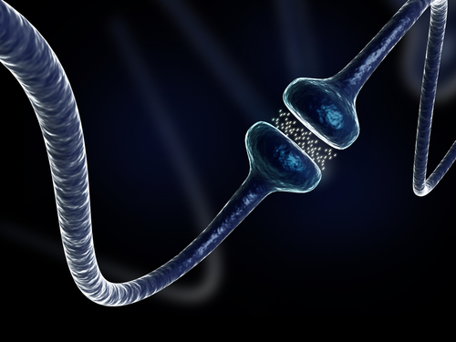

In the nervous system, fast messages between neurons:
Acetylcholine
Dopamine
Endorphins
Serotonin

Hormones
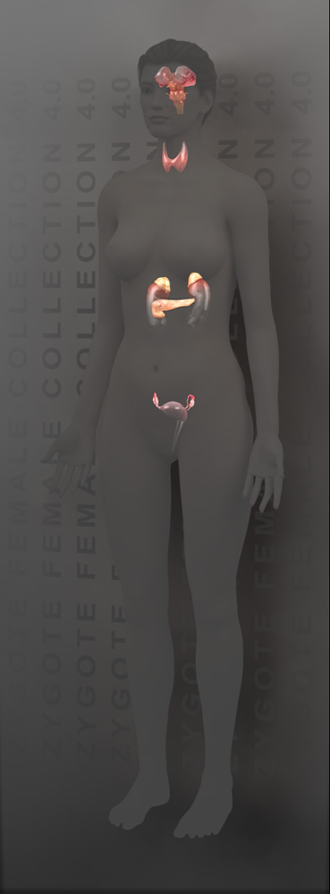
Chemical messages in bloodstream controlled by hypothalamus (endocrine system)
Very slow, but long lasting
Ex. Adrenaline, Testosterone, Estrogen, Orexin, Oxytocin

Lateral hypothalamus
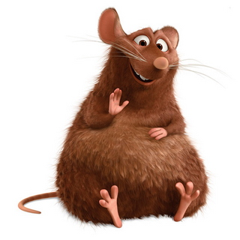

LH=Large Hunger
Stimulates hunger

Ventromedial hypothalamus


VMH=very minute hunger

Suppresses hunger

Broca’s Area
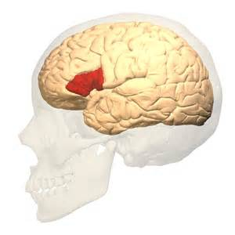

Left frontal lobe-

Makes words

Wernicke’s area
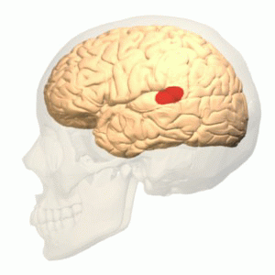

Left temporal lobe-

Comprehends words

Identical twins
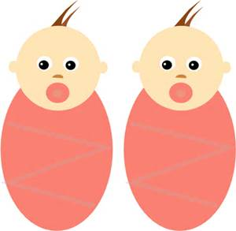

Same fertilized egg; monozygote

Vital for studies in nature vs. nurture

Fraternal twins
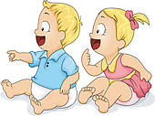

Two separate eggs; dizygotic
Just like any other siblings

Afferent neurons
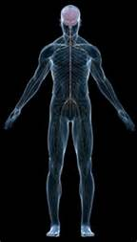

Sensory neurons- info from body to brain

Efferent neurons

Motor neurons-
brain sends messages to body

(Takes effort to move hand, etc)

Assimilation
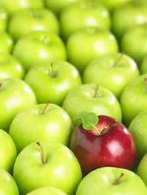

Incorporate our experiences into existing schemas

Ex. All four-legged animals are “doggies”

Accommodation
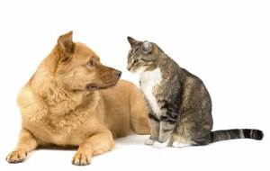

When info violate schema, we accommodate and change schema

“doggies” are different than “kitties”

Concrete Operational Stage of Development
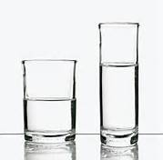
7-11 years

Logical thinking about concrete events

Understand analogies and mathematical operations

Conservation mastered

Formal Operational Stage of Development
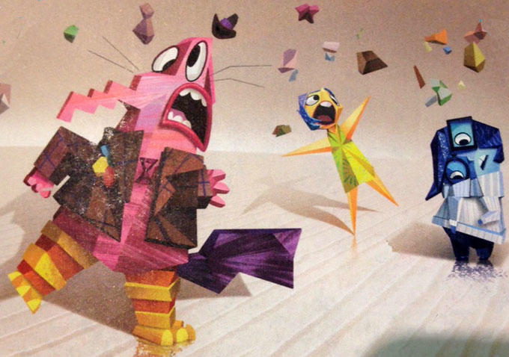
12- adulthood

Philosophical thinking; Abstract reasoning

Mature, moral logic

Sensation

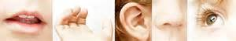

Activation of senses from sensory organs

Bottom-up processing

Perception

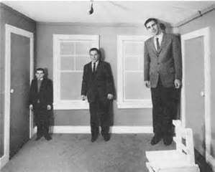

Process of understanding sensations

Top-down processing

Rods

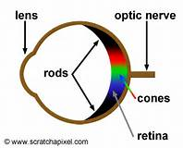

Peripheral Vision

Night vision

Respond to black and white

Outnumber cones

Cones

Color vision

Clustered around the fovea

Classical conditioning
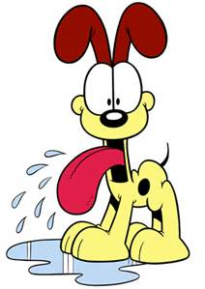

Involuntary/reflexive response to stimuli

Neutral stimulus paired with unconditioned stimulus to produce similar response

Operant conditioning

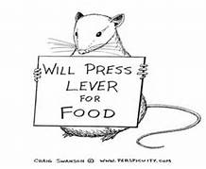
Voluntary

Active change in behavior resulting from rewards or consequences that follow response

-Goal oriented

Primacy effect

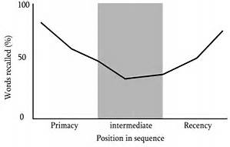

Part of serial position effect

First items on list are remembered

Ex. Founding fathers

Recency effect

Part of serial position effect

Last items on list remembered

Ex. Presidents from your lifetime

Proactive interference
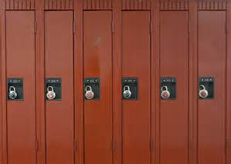

P.O.R.N.

Old information interferes with remembering new info

Retroactive
Interference
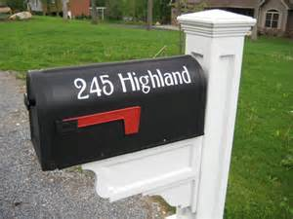
P.O.R.N.

New info interferes with remembering the old info

Implicit memory
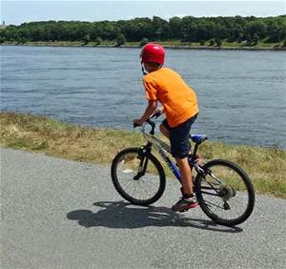

Non-declarative; procedures and skills
Difficult to explain

Cerebellum

Explicit memory

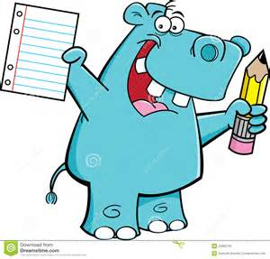
Declarative; episodes of events and facts

Amygdala, hippocampus, thalamus

(hippo on campus? you would remember)

Recall memory


No cues to assist in remembering-

Short answer, free response, etc.

Recognition memory

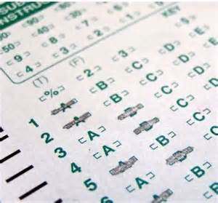

Some hints/context cues

Ex. Multiple choice questions

Algorithms
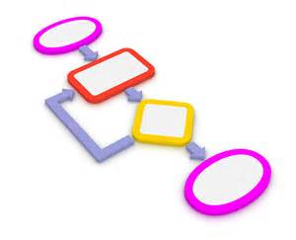

Step-by-step formula to solving a problem

Takes time, but ensures accuracy

Heuristics
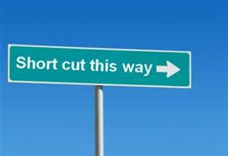

Rule-of-thumb, shortcut

Much faster than algorithm, but less accurate

